TEAMUP DESIGN SPECIFICATIONS

## HIGH LEVEL SYSTEM ARCHITECTURE

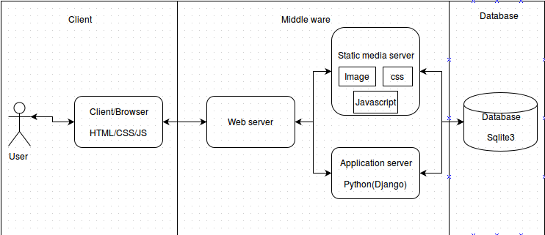

## ER DIAGRAM



# ER DIAGRAM ENTITY ATTRIBUTES

|  |  |
| --- | --- |
| **User** | |
| **Field** | **Type** |
| fname | Char(128) |
| sname | Char(128) |
| email | Char(128) |
| username | Char(50) |
| password | Char(150) |

|  |  |
| --- | --- |
| **UserProfile** | |
| **Field** | **Type** |
| phone_number | Char(15) |
| picture | Char(100) |
| about_me | Text |
| user ref User | Integer |
| role | char(15) |

|  |  |
| --- | --- |
| **Course** | |
| **Field** | **Type** |
| code | char(15) |
| name | char(100) |
| course_password | char(15) |
| team_size | Integer |
| add_date | Datetime |
| creator ref User | Integer |
| slug | Char(150) |

|  |  |
| --- | --- |
| **Team** | |
| **Field** | **Type** |
| name | char(100) |
| course ref Course | char(15) |
| current_size | Integer |
| creation_date | Datetime |
| required_skills | Text |
| description | Text |
| creator ref User | Integer |
| slug | Char(150) |
| status | Boolean |
| merge_with ref Team | Integer |

|  |  |
| --- | --- |
| **MemberRequest** | |
| **Field** | **Type** |
| user_id ref User | Integer |
| team ref Team | Text |
| status | char(10) |
| request_date | Datetime |